Storybook Guidelines Checklist Name ____________________________

Book Cover:
________ Title
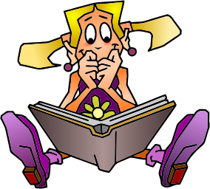
________ Illustration
________Author

Inside Pages of Story (on each page):
________ Illustration
________2-3 Sentences

End Page:
________About the Author
________Dedication?

Back Cover:
________ Publisher Name
________ Copyright Logo and Year

